EXPECTED PYTHON FILES OUTPUT

NAME :THEERTHA N S
BATCH 2 DATA ENGINEER

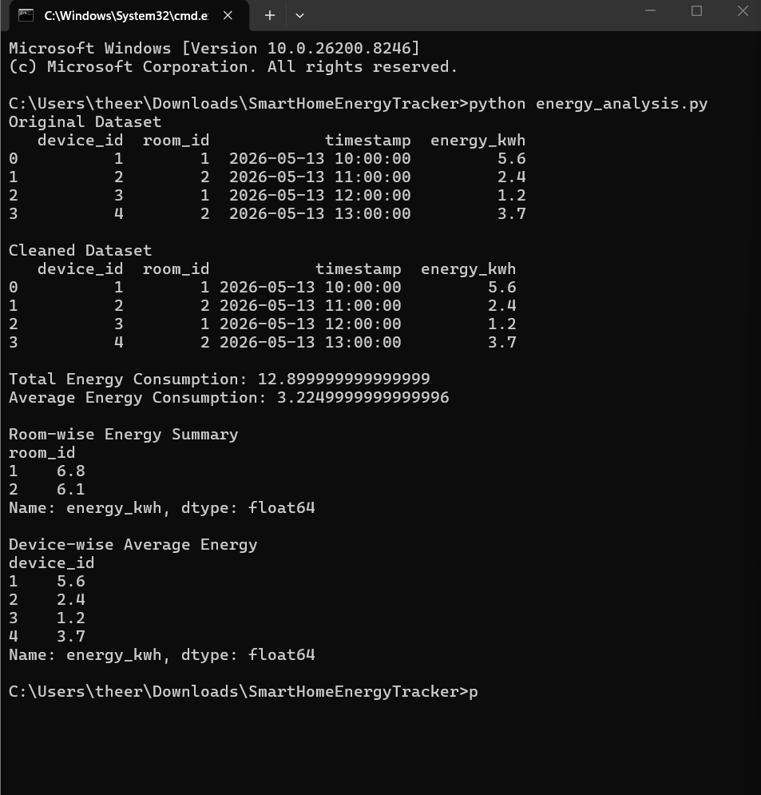

OUTPUT 1

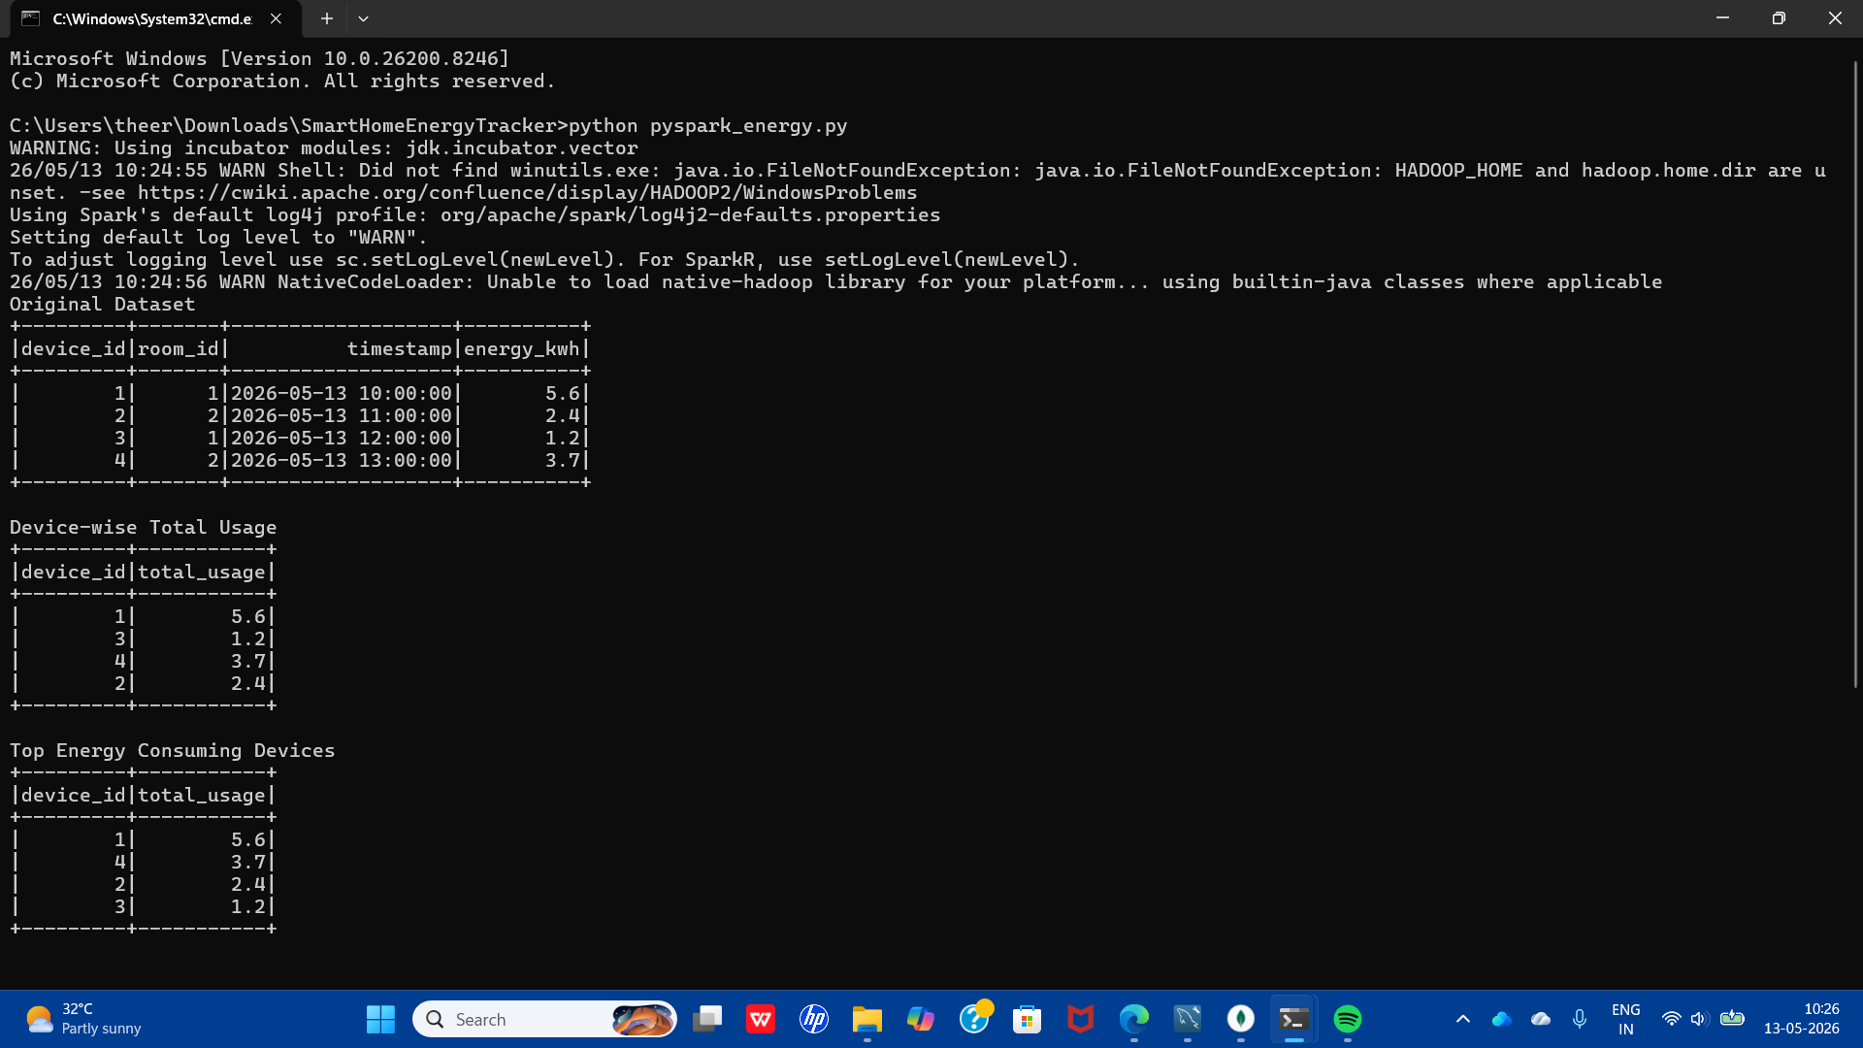

OUTPUT 2

